Lesson plan 2: Images and lists

About the lesson
In this lesson, students will learn how to embed images into an HTML file and how to adjust the presentation by floating elements on a page and adding margins around elements. They will also learn how to present information as an ordered or unordered list. They will apply this learning to practical activities using the HTML and CSS files provided.
Learning objectives
By the end of this lesson, students will be able to:
- embed an image into an HTML document
- float elements and add margins to control the layout of a web page
- write ordered and unordered lists.
National Curriculum
The following subject content from the KS3 National Curriculum is included in this lesson:
- Use two or more programming languages, at least one of which is textual, to solve a variety of computational problems
- Undertake creative projects that involve selecting, using and combining multiple applications, preferably across a range of devices, to achieve challenging goals and meeting the needs of known users
- Create, reuse, revise and repurpose digital artefacts for a given audience, with attention to trustworthiness, design and usability
Links
Websites are integral to modern life and link to every area of the curriculum and beyond. Students could be encouraged to create or develop their own images for use in this lesson, using skills from the ‘Getting Started’ module.
Key terminology
attribute, unordered list, ordered list
Teaching and learning activities
Share the objectives for the lesson with students (Slide 2 of Lesson 2 presentation).
Starter
Show students an image of a web page including an image and a list and ask: Why might we add an image to a web page? (Slide 3).
Answers may include: to break up the text, to make the web page more interesting, to help illustrate a point made in the text.
Part 1
Explain how images are embedded in a web page and how they are displayed (Slides 4–5 and page 153, plus Video 2.1).
Ask students to complete Activity 2.1: Embedding an image (Slide 6, page 153/Worksheet 2.1, plus lesson2_index.html and lesson 2_style.css).
Common misconceptions
Many students do not appreciate that images for a website need to be stored in a single folder along with the html and css files so that they can be located and displayed. This is also the case for live websites, where the images will be uploaded to the same folder on a web server as the other files. If an image does not display, direct students to check that the image has been saved into the correct folder, and that the file name is an exact match, including capitalisation.
Example answers
Students are selecting their own image so the file name will vary. However, the HTML code should look like this:
If the image is not displaying correctly:
- Make sure that the image is saved to the same folder as 'lesson2_index.html' and 'lesson2_style.css'.
- Check that the file name and extension used for the source in the HTML document is exactly the same as the image's file name and extension.
- Make sure that 'lesson2_index.html' has been saved and the browser refreshed.
The completed web page should look something like this:
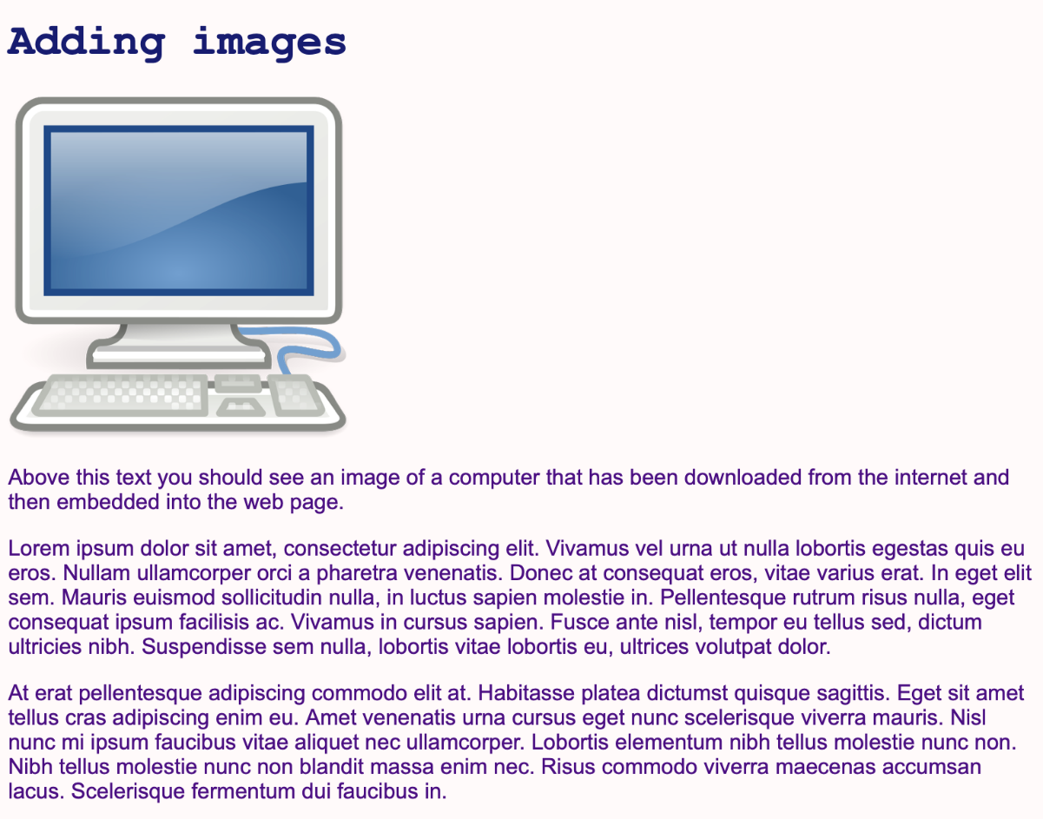
Explain how to use the float and clear properties (Slides 7–8 and page 153, plus Video 2.2).
Ask students to complete Activity 2.2: Floating an image (Slide 9, pages 153–154/Worksheet 2.2, plus lesson2_index.html and lesson 2_style.css).
Answers
1.
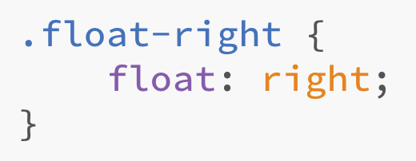
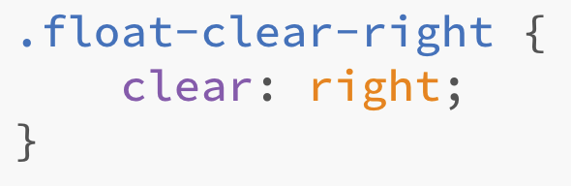
2. a.
b.
The finished web page should look something like this:
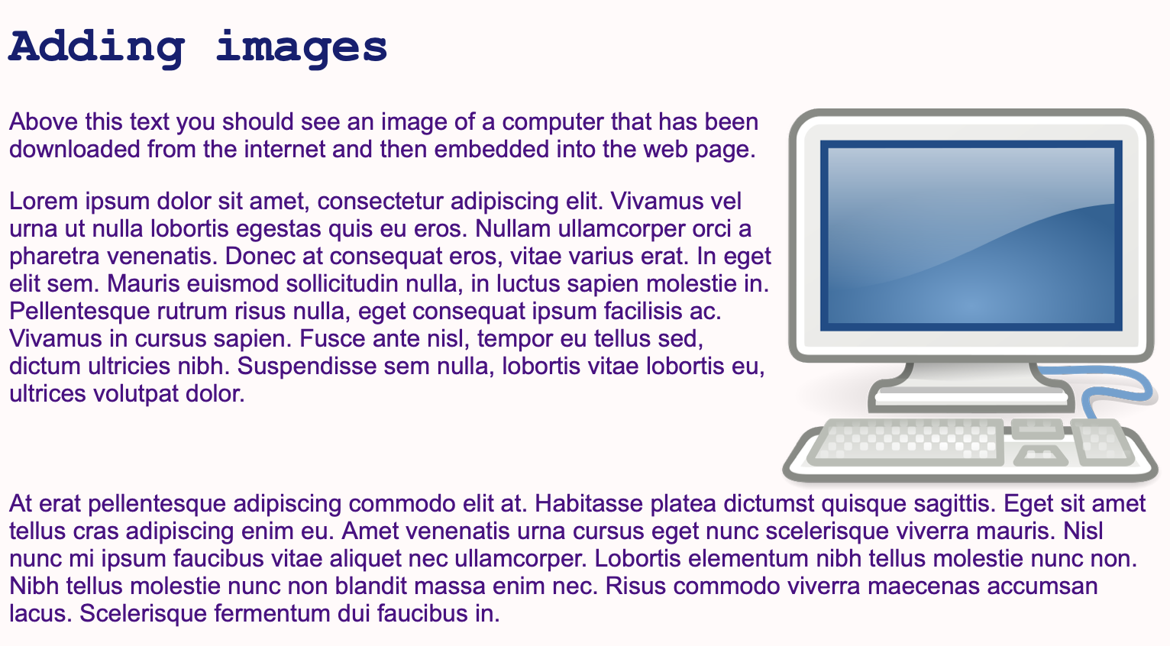

Explain how the margin property can be used to create space around elements (Slide 10 and page 154, plus Video 2.3).
Ask students to complete Activity 2.3: Adding a margin (Slide 11/page 154/Worksheet 2.3, plus lesson2_index.html and lesson 2_style.css).
Answers
1.
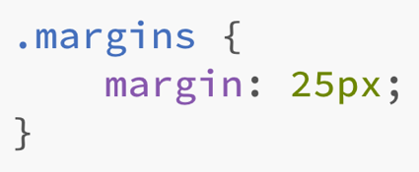
2.
The finished web page should look something like this:
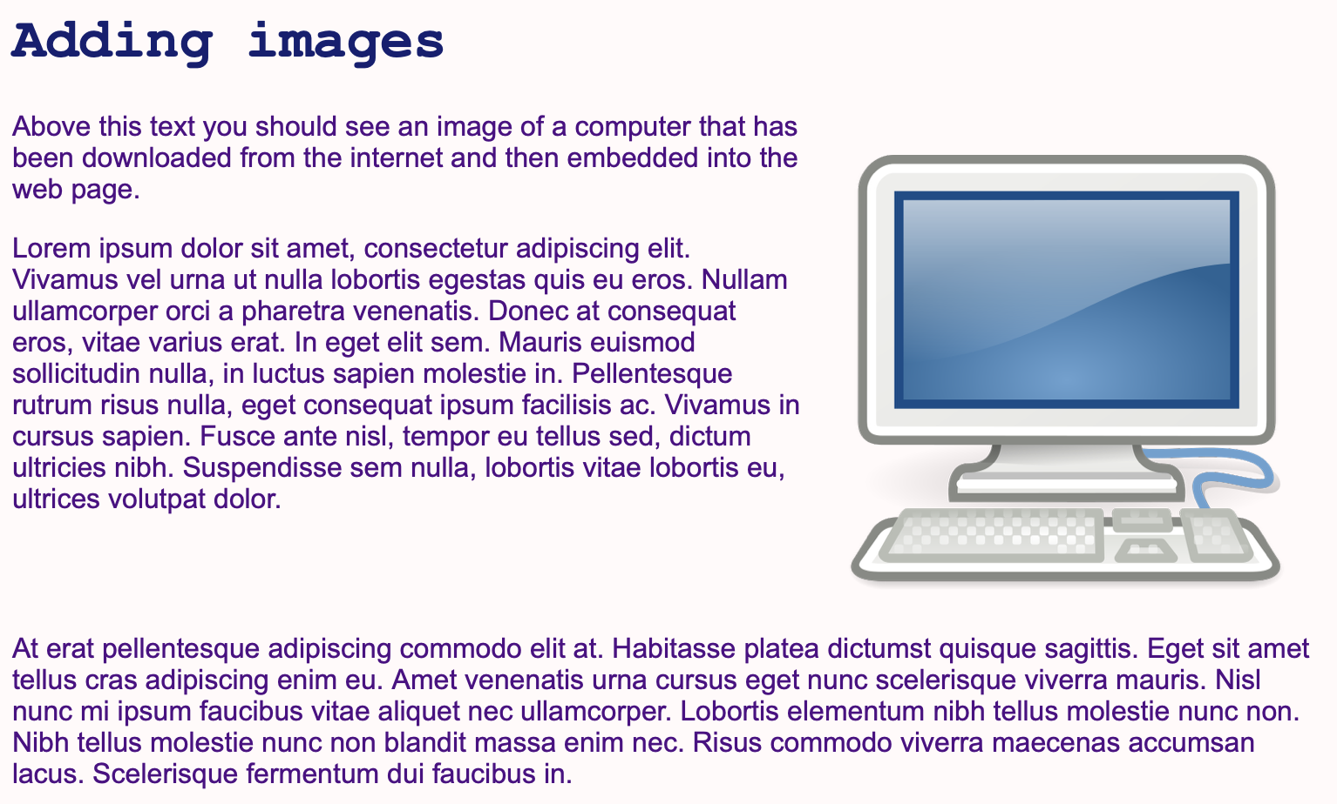
Part 2
Explain unordered and ordered lists (Slides 12–13 and page 154, plus Video 2.4).
Ask: Give me an example of a list that is best ordered.
Examples of lists that are best ordered include recipes, questions in a textbook and instructions for wiring a plug.
Ask: Give me an example of a list that is best unordered.
Most lists are best unordered, including lists of names, lists of places and lists of facts.
Ask students to complete Activity 2.4: Creating lists (Slide 14/pages 154–155/Worksheet 2.4, plus lesson2_index.html and lesson 2_style.css).
- The output will vary because students are writing their own lists but look for the use of <ul> for the unordered list and <ol> for the ordered list.
- Make sure that each item in the lists is enclosed between <li> and </li>.
Plenary
Check students' knowledge and understanding with a short question and answer session linked to the learning objectives for the lesson.
- Which tag is used to embed an image?
(Answer: <img>)
- Which two attributes have to be included inside the <img> tag?
(Example answer: The link to the source image and the alternative text that describes the image.)
- What else should you define when embedding an image?
(Example answer: the image's width and height)
- What is the float property used for?
(Example answer: positioning an element on the screen, to the right, left or centre)
- What are the two types of list?
(Example answer: ordered (numbered) lists and unordered (bullet) lists)
Homework
Ask students to complete any activities they did not finish during the lesson.
Ask students to complete Quiz 2 (Slide 15).
Stretch activities
Students who complete the activities in this lesson quickly could be encouraged to add a second image of their choosing to a web page and try floating it to a different position. They could also experiment with adjusting just the width of the image; they should find that the height will adjust automatically.
Support activities
The most common reasons for images not displaying are that the image has not been saved to the correct folder, or that the file name is not an exact match. Support students directly in resolving these issues if they occur. When creating the lists, a common error is to forget to add the closing tag for the first list before beginning the second, which will affect the appearance on the screen. Encourage students to use appropriate indentation to help with reading the HTML code and checking that closing tags have been included.
An additional explanation about inserting images into web pages can be found at https://www.w3schools.com/html/html_images.asp

